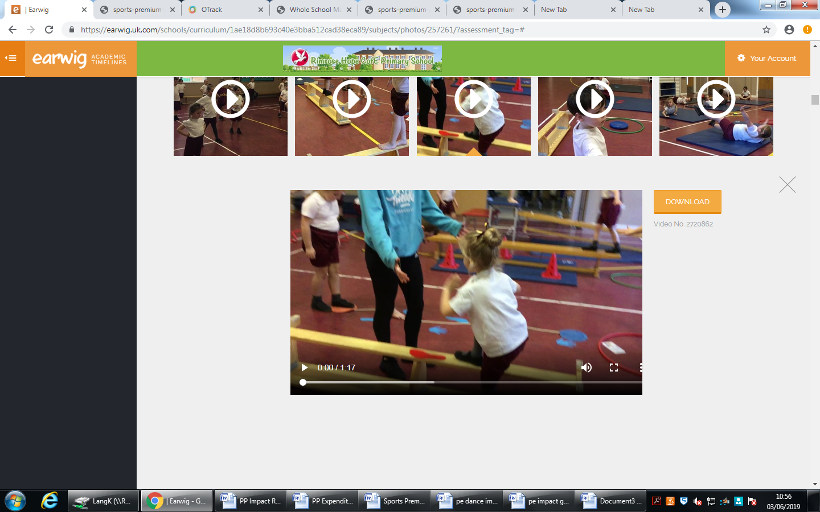
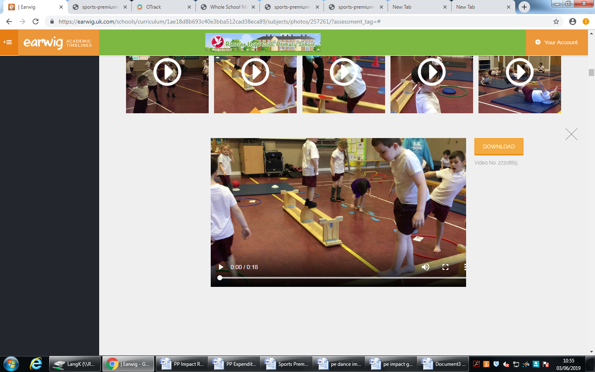
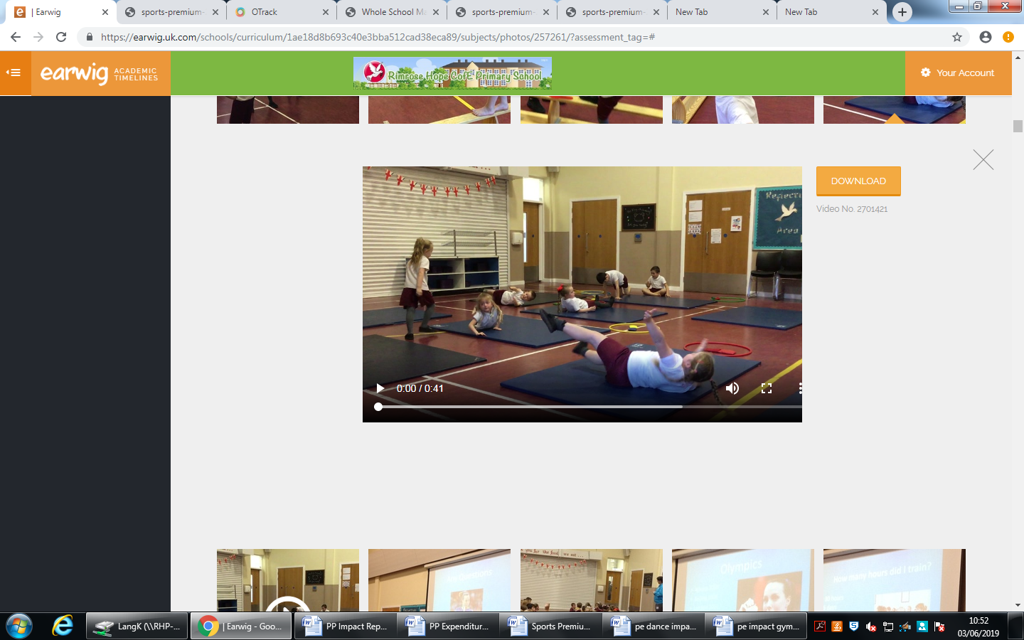
Progression in Gymnastics Year 1/2 Expected
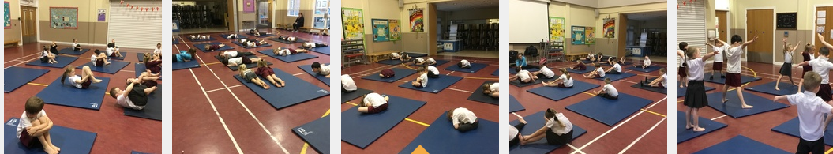
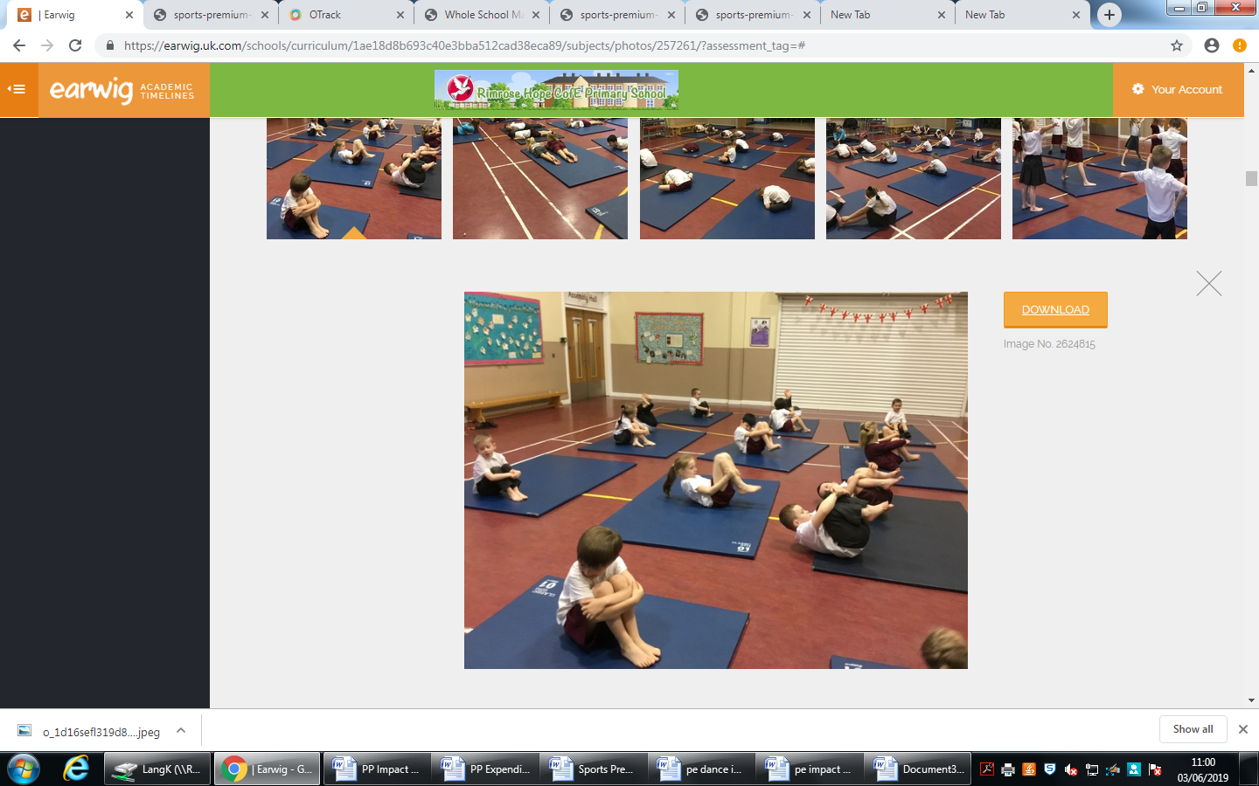
The children have worked with the coaches from the Beth Tweddle Gymnastics Academy. Children have begun to develop their basic skills in balancing and co-ordination, rolling, travelling on mats and benches and creating simple sequences.
Gymnastic Sequences Earwig P.E Spring 2 Year 1/2

