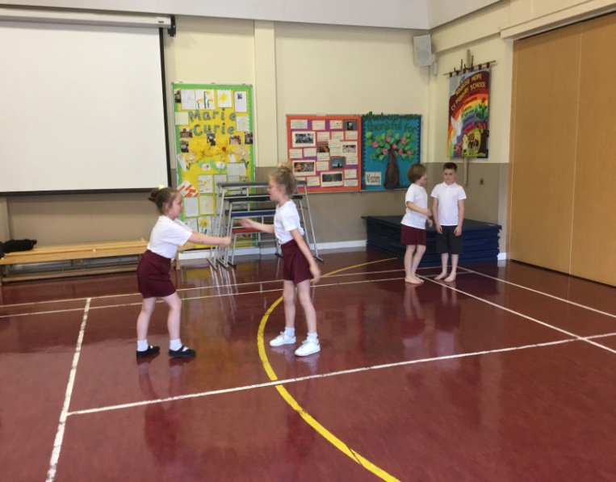
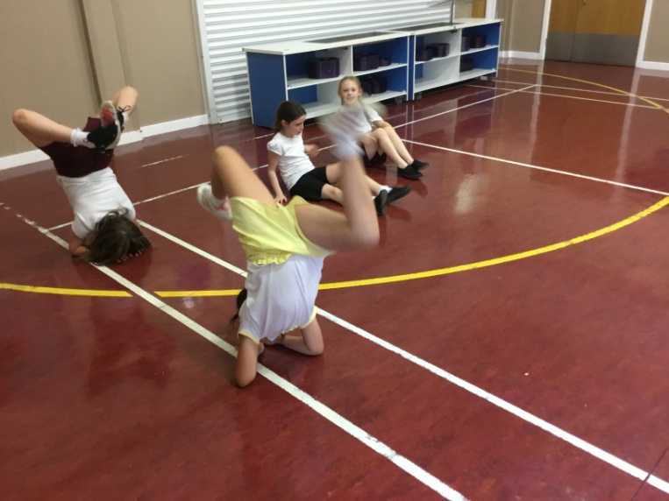
Progression in Dance Year 1/2 Expected

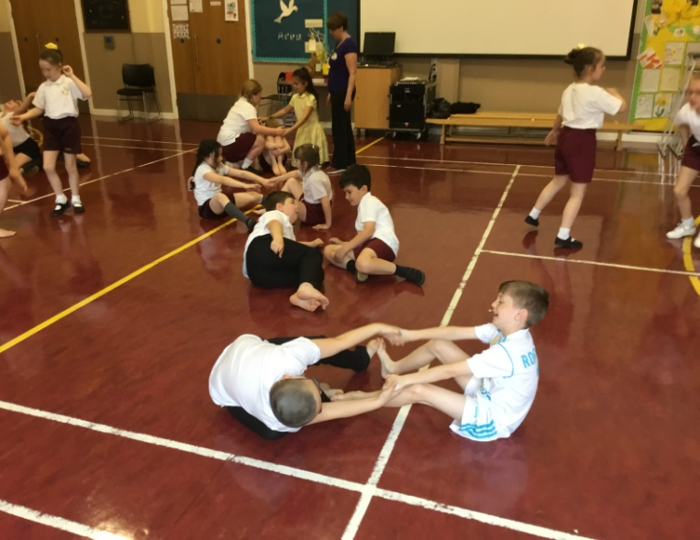
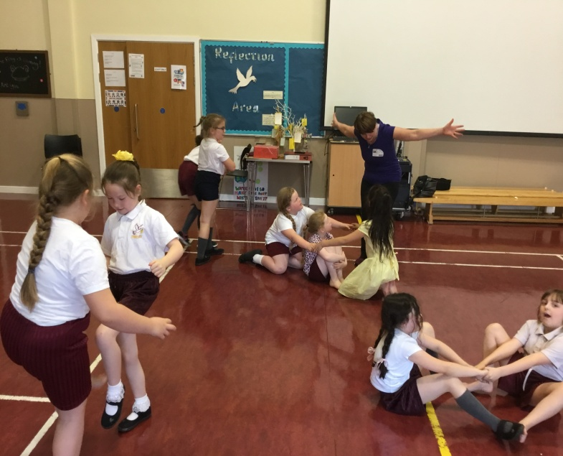
The children worked over a 5 session block of dance lessons with Mrs Hardman. Their topic was the Solar System. They had to work together to create a sequence of movements that linked together and showed the different dynamics of dance- twists, lower level movements and high level movements.
Dance performance Earwig Yr 3 /4 Solar System Spring 2

